CS 255 System Design Document

UML Diagrams

UML Use Case Diagram
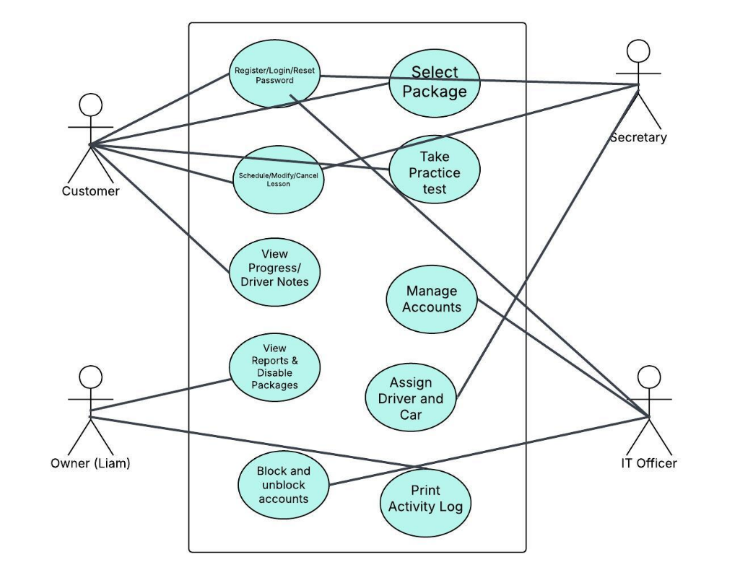

UML Activity Diagrams
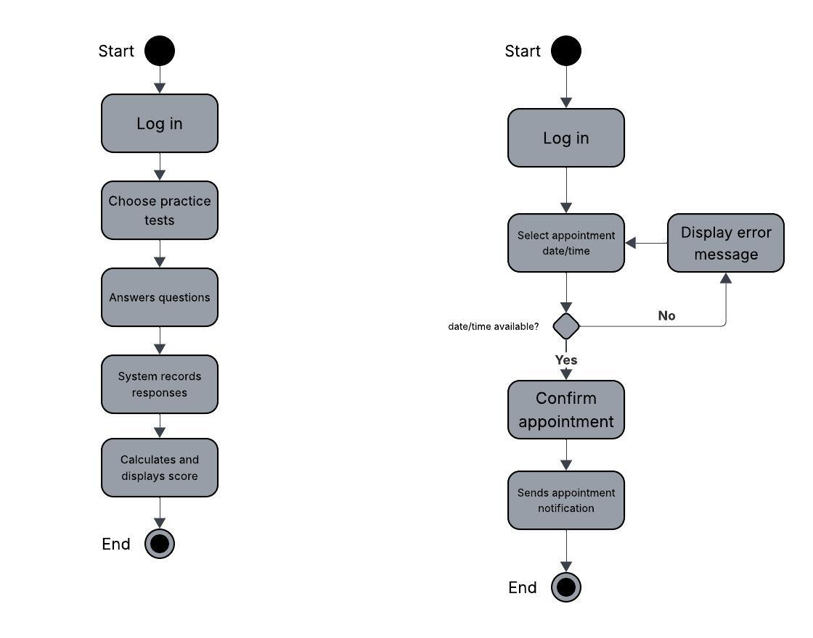

UML Sequence Diagram
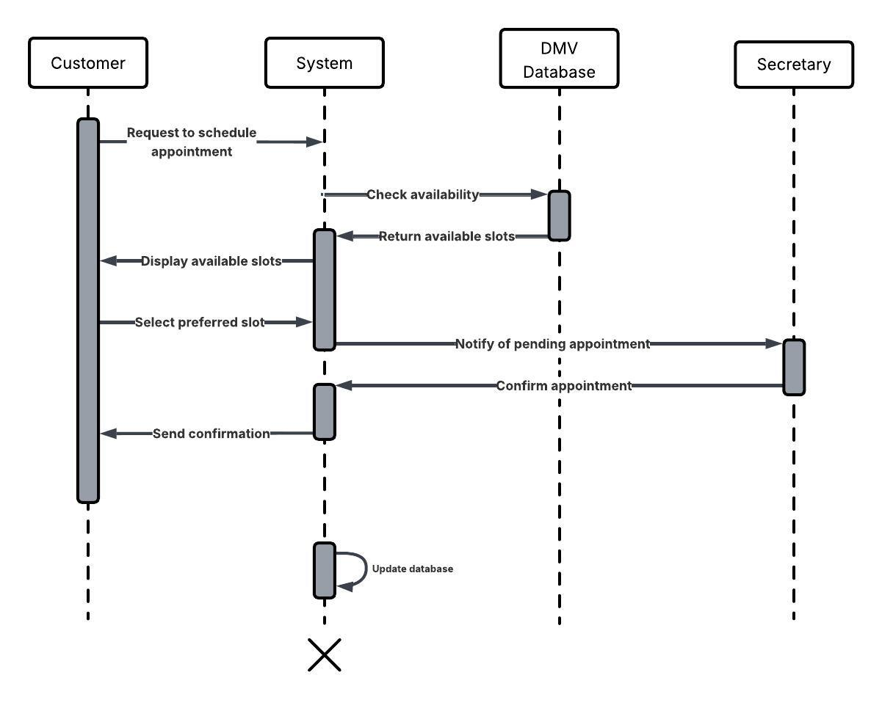

UML Class Diagram
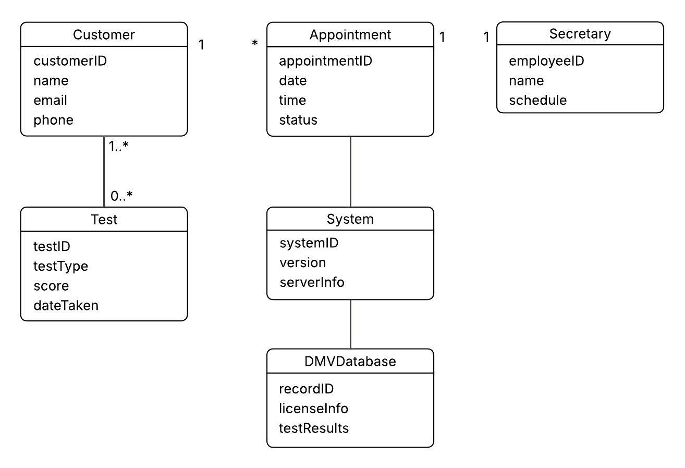

Technical Requirements

The DriverPass system will operate as a secure, web-based application that customers and staff can access through standard internet browsers on desktops, laptops, tablets, or smartphones. A cloud hosted server environment will store and manage all system data, including customer accounts, appointments, test results, and reports. Office staff will need reliable computers and internet access to manage scheduling, assign instructors and vehicles, and review reports. The system will use a relational database to organize information and ensure accurate record keeping. Development and modeling tools such as Lucidchart were used to design the system structure, and standard development environments will be used to build and maintain the application.

To meet security and performance expectations, the system will include secure login authentication, encrypted data storage, role-based access controls, and automatic session timeouts. A stable internet connection is required for real time scheduling and practice testing features. Cloud infrastructure allows the system to scale as DriverPass grows, while routine data backups and monitoring tools ensure reliability and prevent data loss. Together, these technical requirements support the system’s core functions while ensuring it remains secure, accessible, and dependable.

